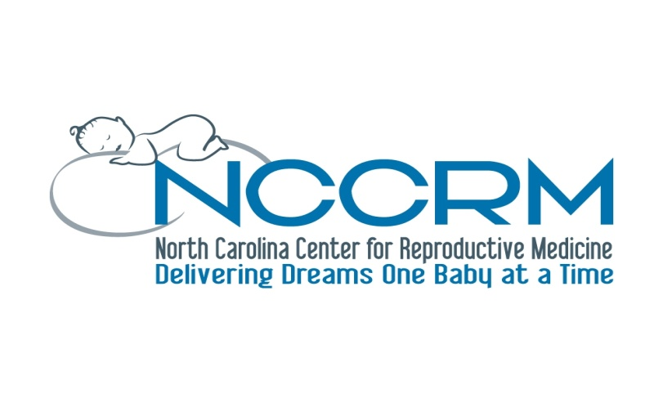
400 Ashville Ave. Ste. 200
Cary, NC 27518
Ph: 919-233-1680
Fax: 919-233-1685

Consent to proceed for Tubal Reversal Surgery without submitting my prior tubal ligation Medical records.

I___________________________________________________________________, agree to proceed with

Tubal reversal surgery at (NCCRM) without submitting my previous medical records and the
operative notes for my prior tubal ligation procedure. I request and authorize the physicians
and the staff at NCCRM to perform any diagnostic procedures, treatment procedures, and
operative procedures related to the tubal reversal surgery. I also have not been given a
guarantee as to the results of surgery without having my prior records and the tubes may be
too short to repair or absent.

I release NCCRM and its staff from any claim or liability due to the proceeding for tubal
reversal surgery without having my prior records.

Signature: ____________________________________________________________

Date: _________________________________________________________________

